|  |  |
| --- | --- |
| Sketchbook - For everyone who loves to draw  Digital media sketchbook  Eric Spiteri 5.1 Interactive | Abstract  Task 2  Eric Spiteri  MCAST Advanced Diploma in Creative Media Production |

Contents

Sketches 3

40 chosen images 9

Production 21

Introduction

I have chosen to create an interactive experience based on a wild dream I had involving weird transformations of the universe.

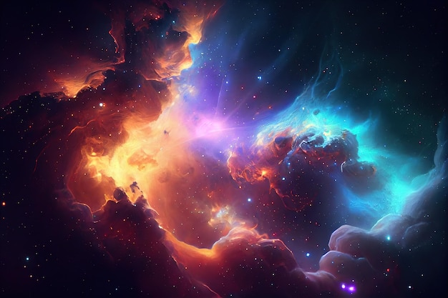I have always been fascinated with space and cosmology and have consumed lot’s of media regarding this subject which should give me plenty of visual ideas.

# Sketches

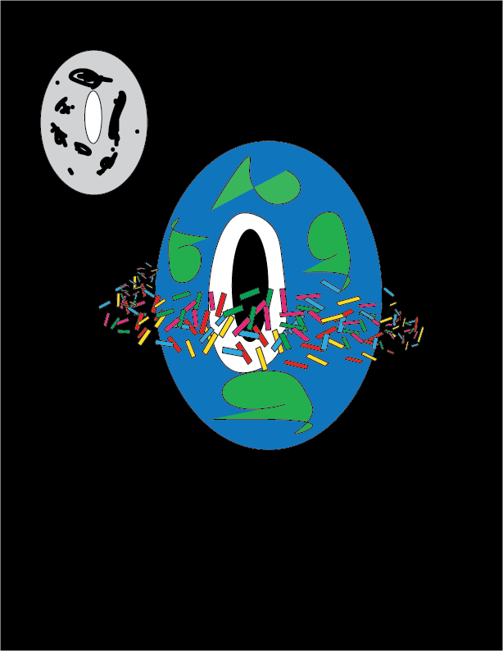 Sketch 1: “Doughnut Earth”

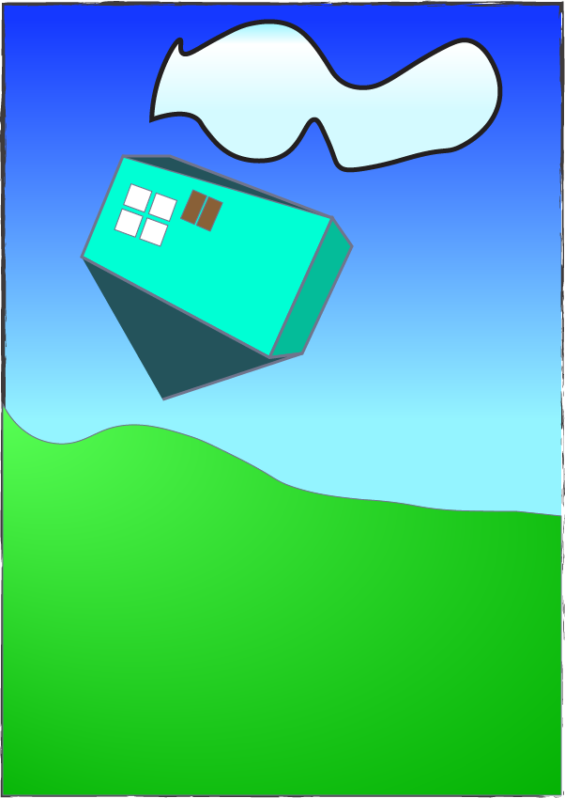

Sketch 2: “Gravity Switch”

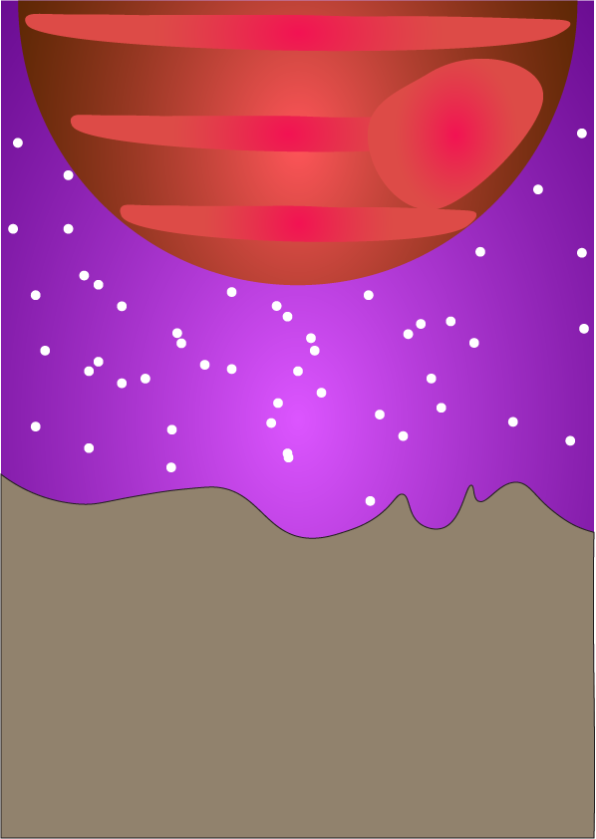

Sketch 3: “Moon Doom”

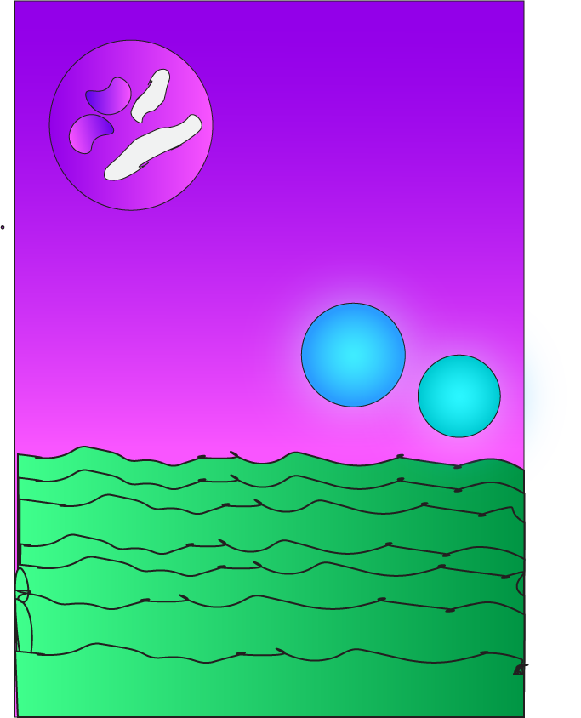

Sketch 4; “Alien Ocean Sunset”

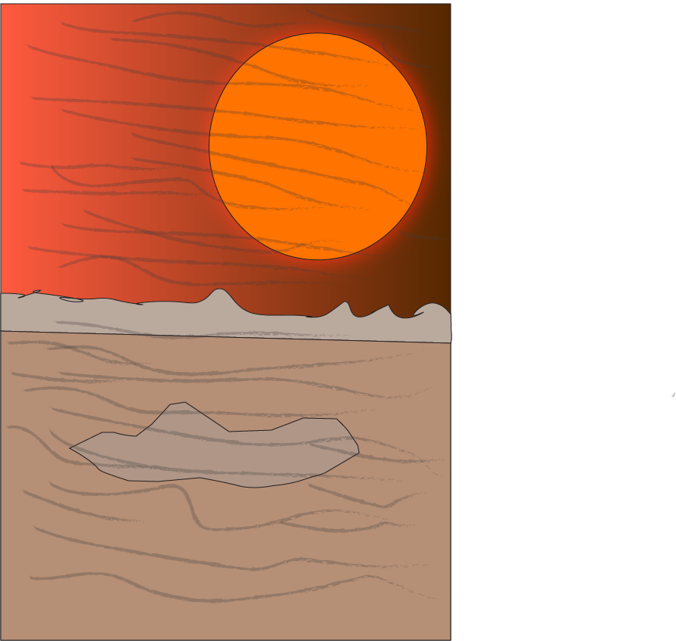

Sketch 5; Scorched Desert

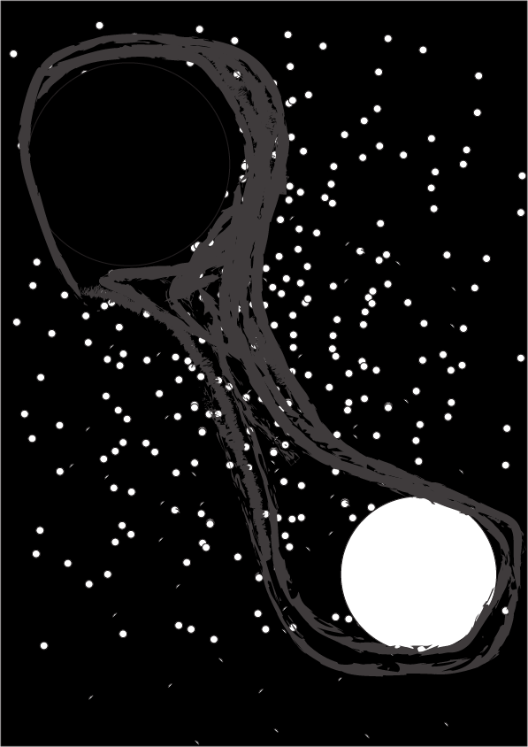

Sketch 5: “Battle of the holes”

# 40 chosen images

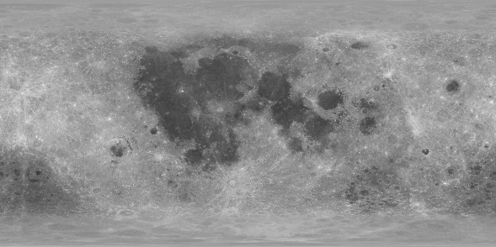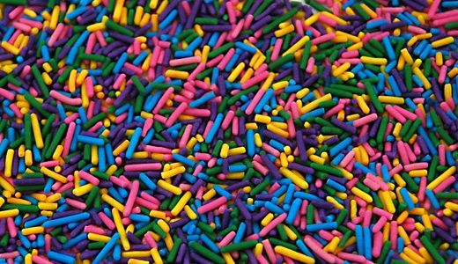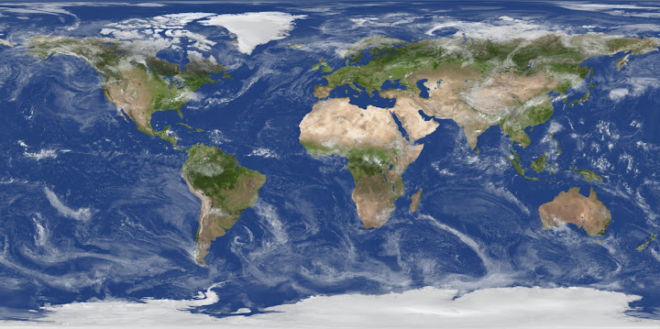

-These are the textures for the dohnut earth concept

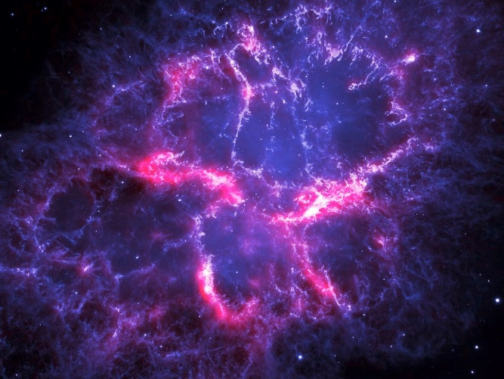

-I chose this purple nebula background because it’s color palette adds to the bizarre nature of the dohnut earth scenario.

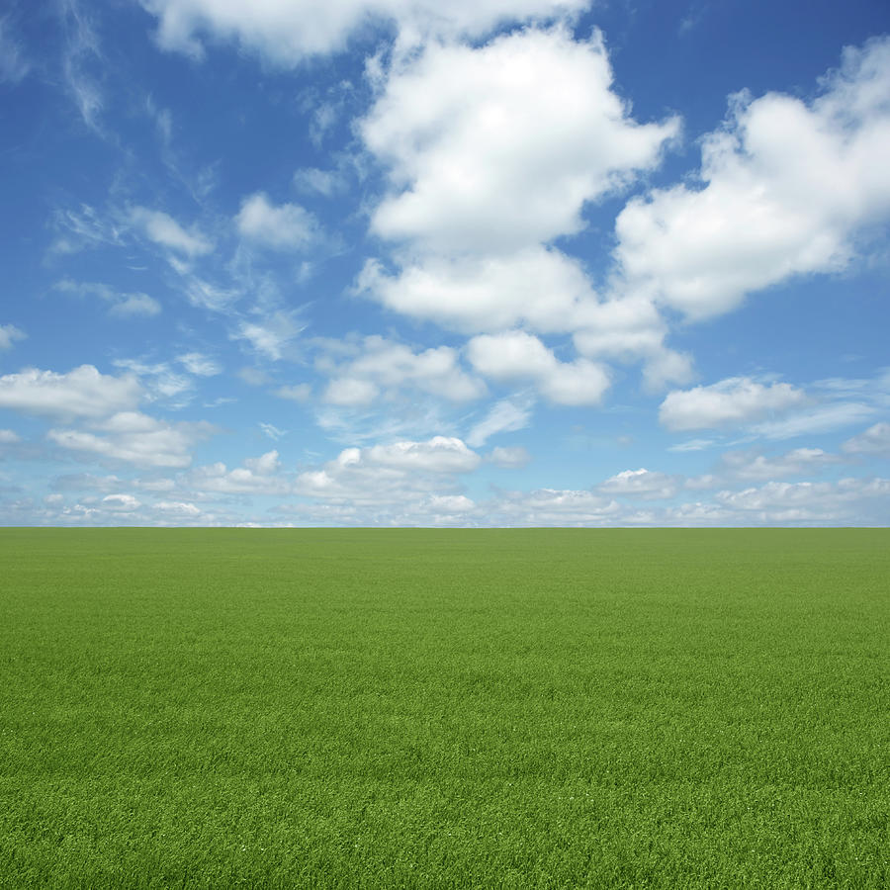

-This seems like a good peaceful backdrop for a contrasting chaotic reversed gravity scenario. Adds to the bizarreness of the image.

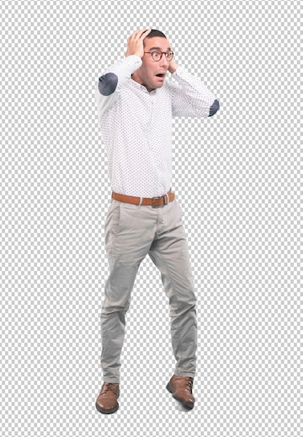

-Shocked human, appropriate for this situation.

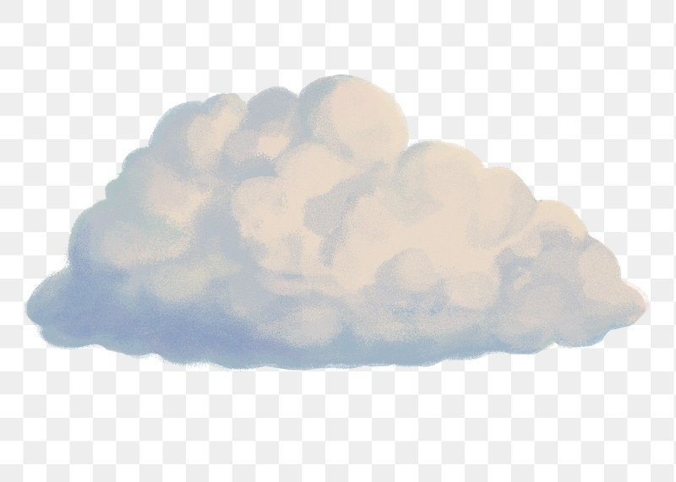

Nice serene and fluffy clouds for extra bizarre contrast to the situation.

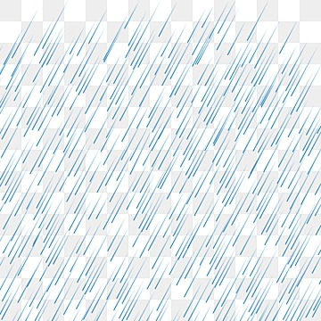

Raindrops that I will flip



House that I will crop and flip.

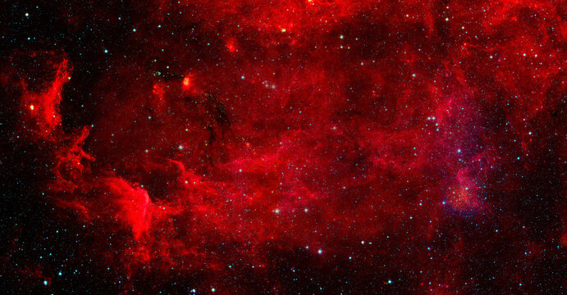

Red nebula background for hellish effect.

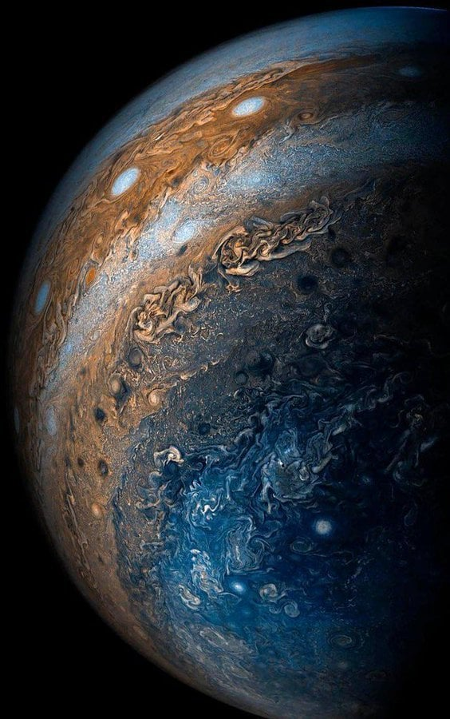Jupiter up close in the sky for sense of danger

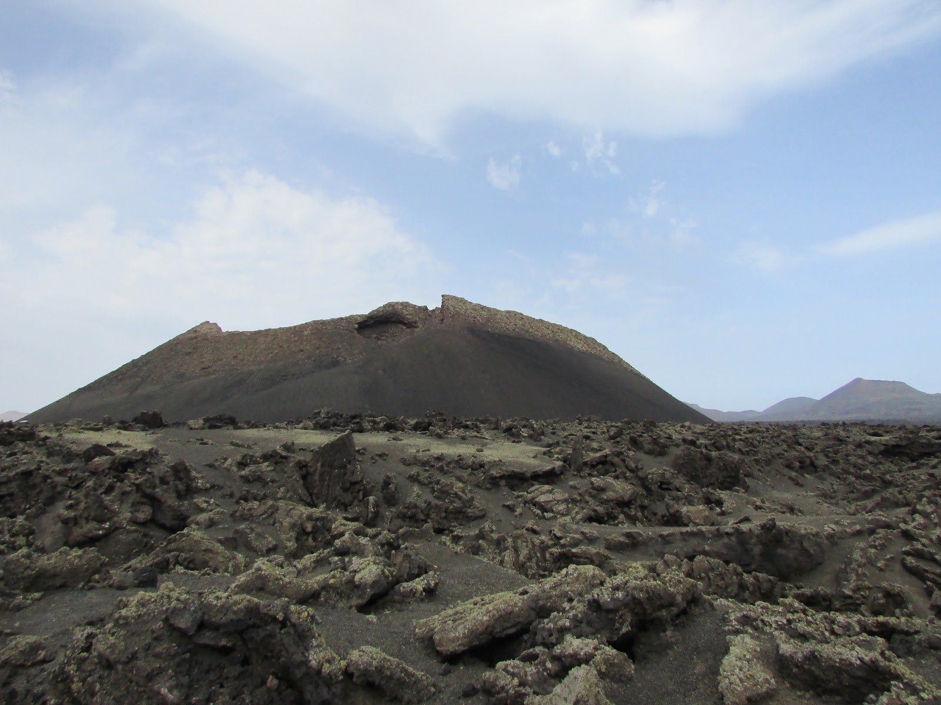

-landscape which I will colour correct to a yellow tint for an uncomfortable feeling, as it is a hellhole

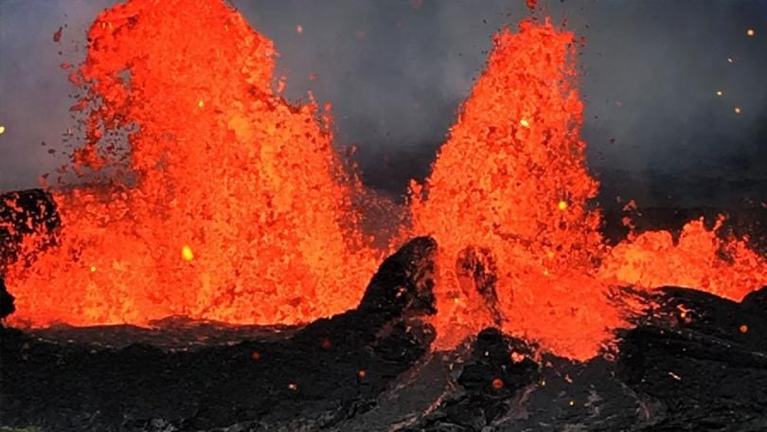

Lava spewing which I will superimpose to add to the hellish effect

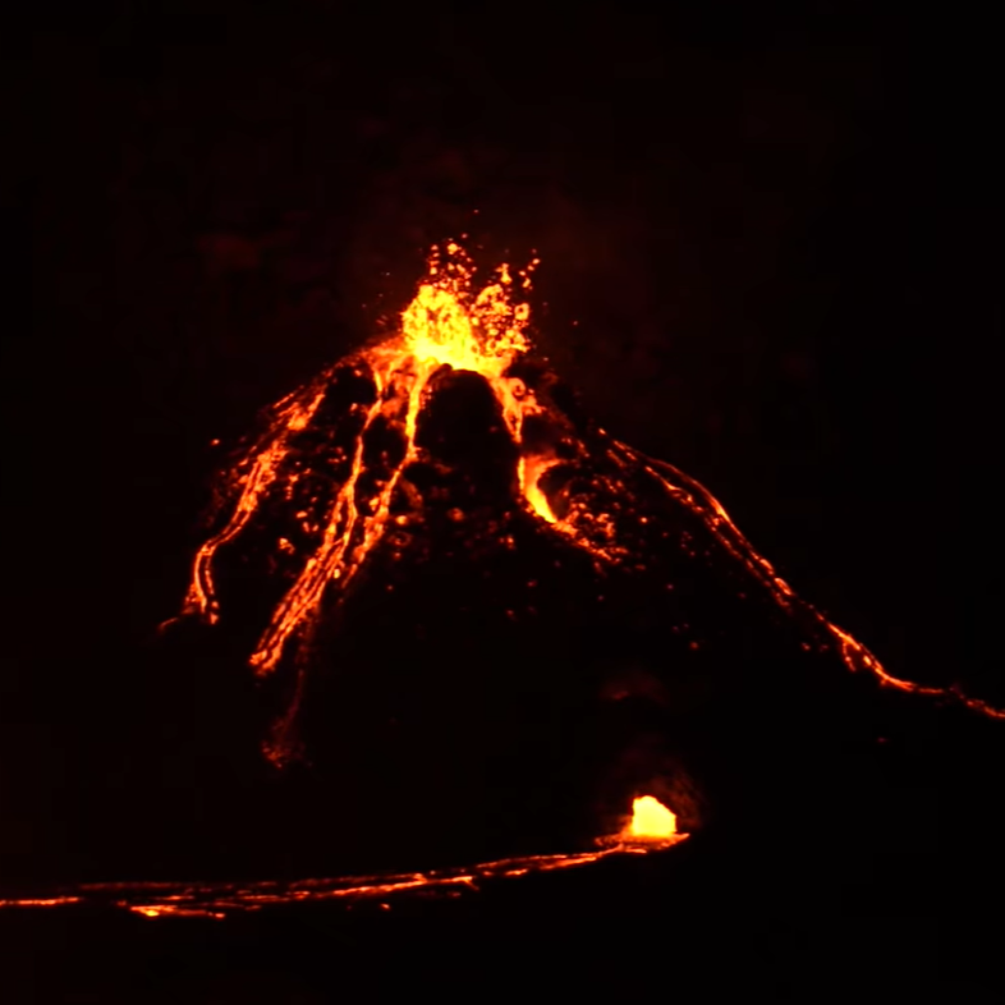

Some more volcanoes in the background

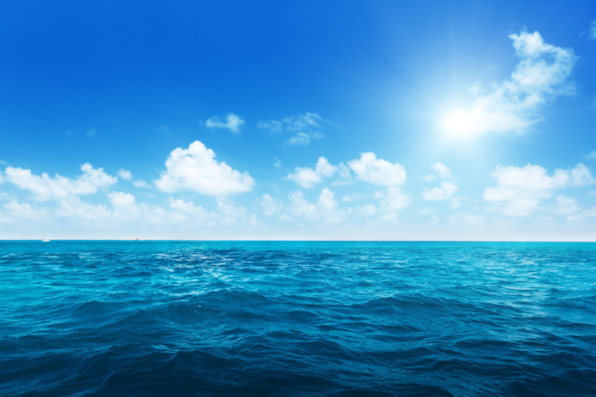

Oceon which I will select and change hue.

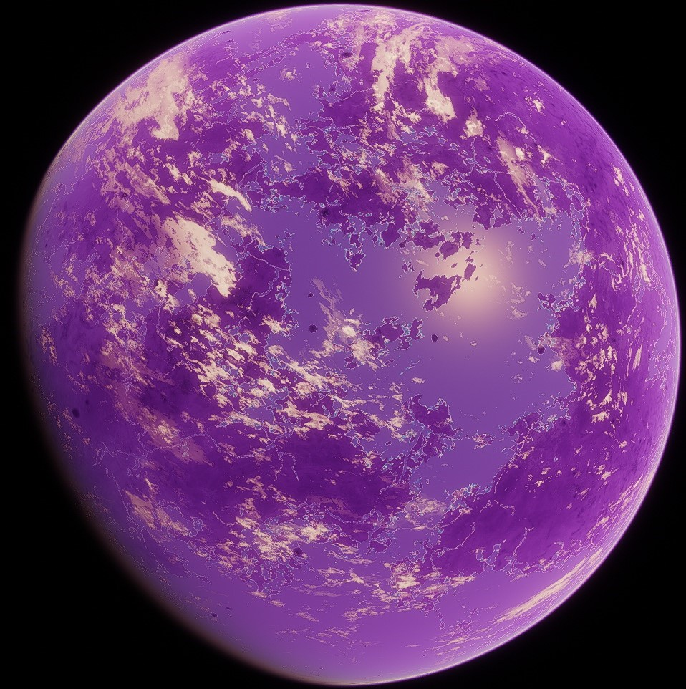

Purple planet which I will then add a glow to in the sky



Clear sky backdrop since I want to add things on it

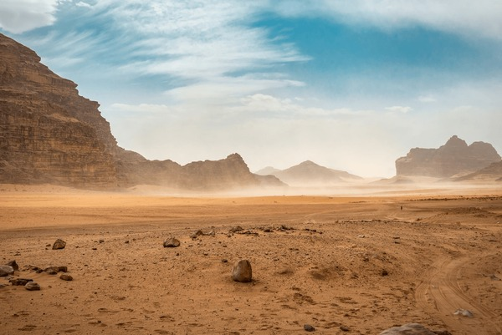Desert foreground, will ad extreme heat waves using morphing and some colour correction to make it darker for a more hellish effect.

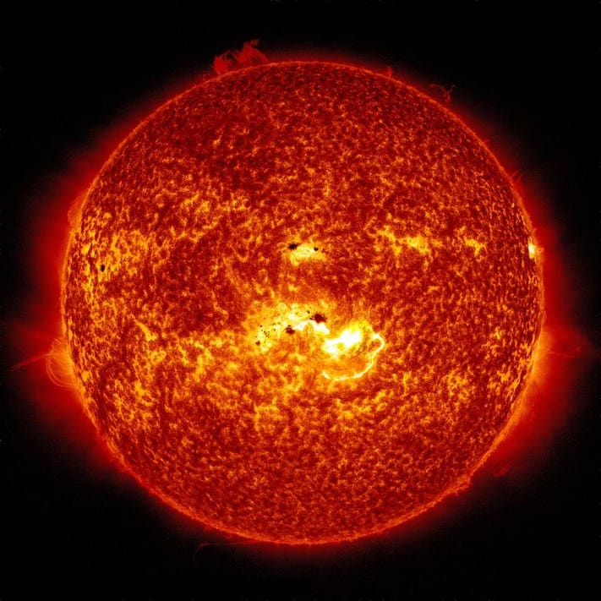

Red giant star that will engulf the sky.

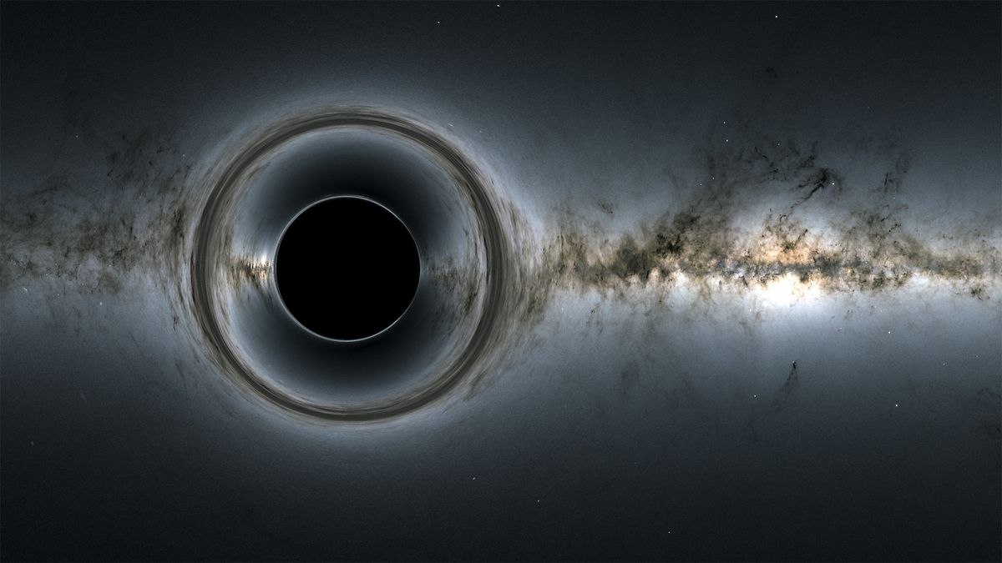

Black hole with background, while add a white dot with morphing to the right for the white hole.

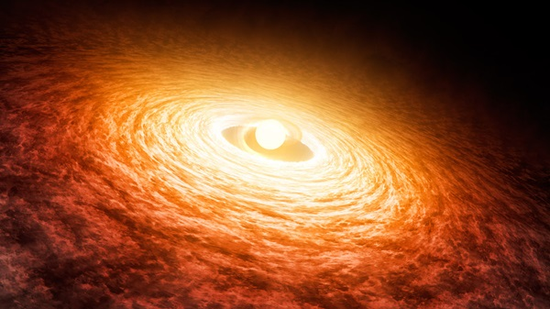

Will take a sample of this gas to use for the battle of resources show in the sketch.

# Production

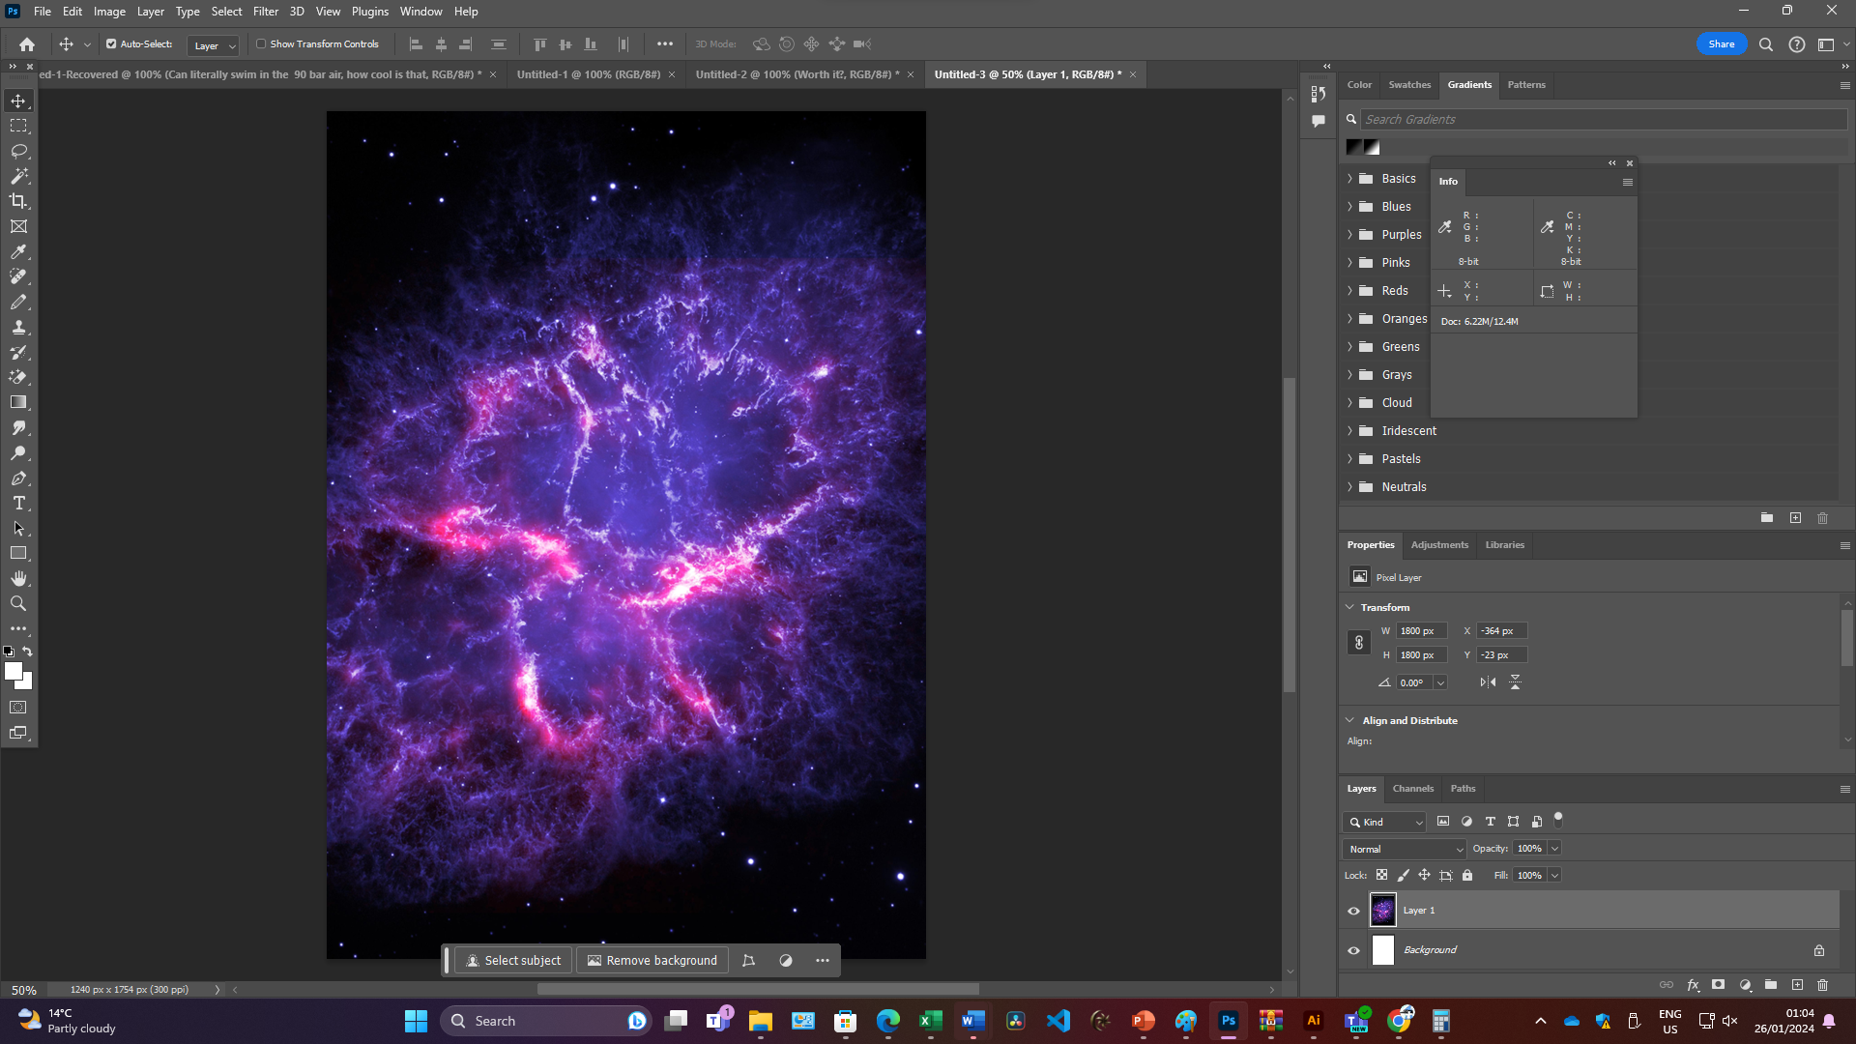

Background

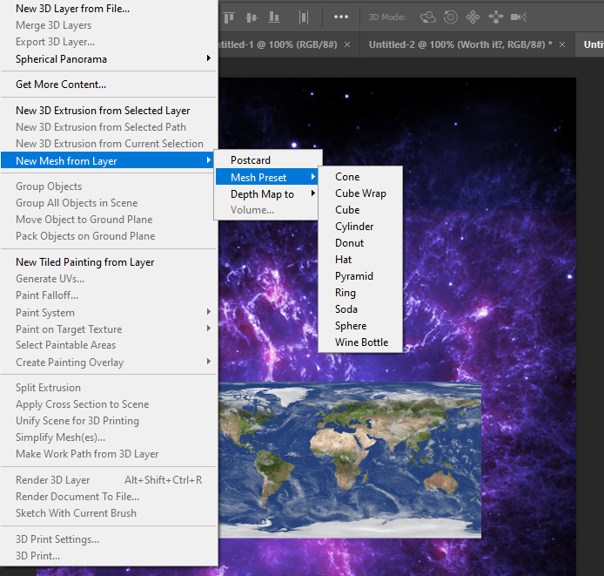

**Creating 3D object using earth texture**

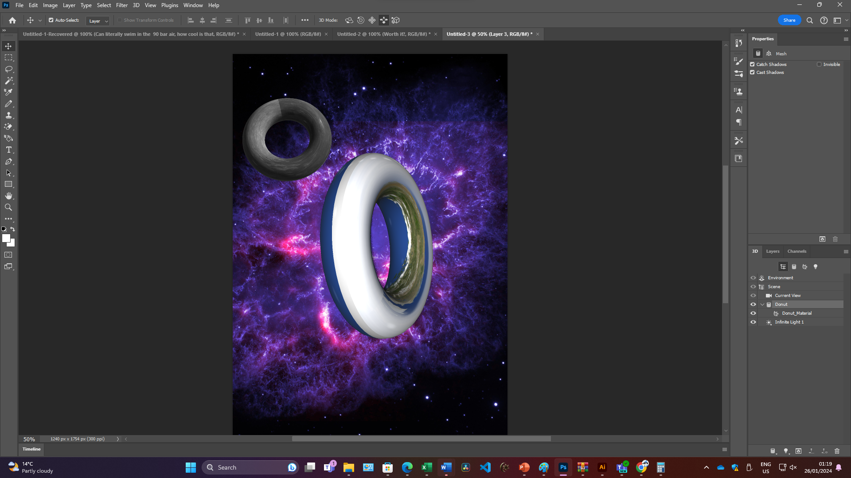

**Both the earth and the moon as doughnuts, yummy!**

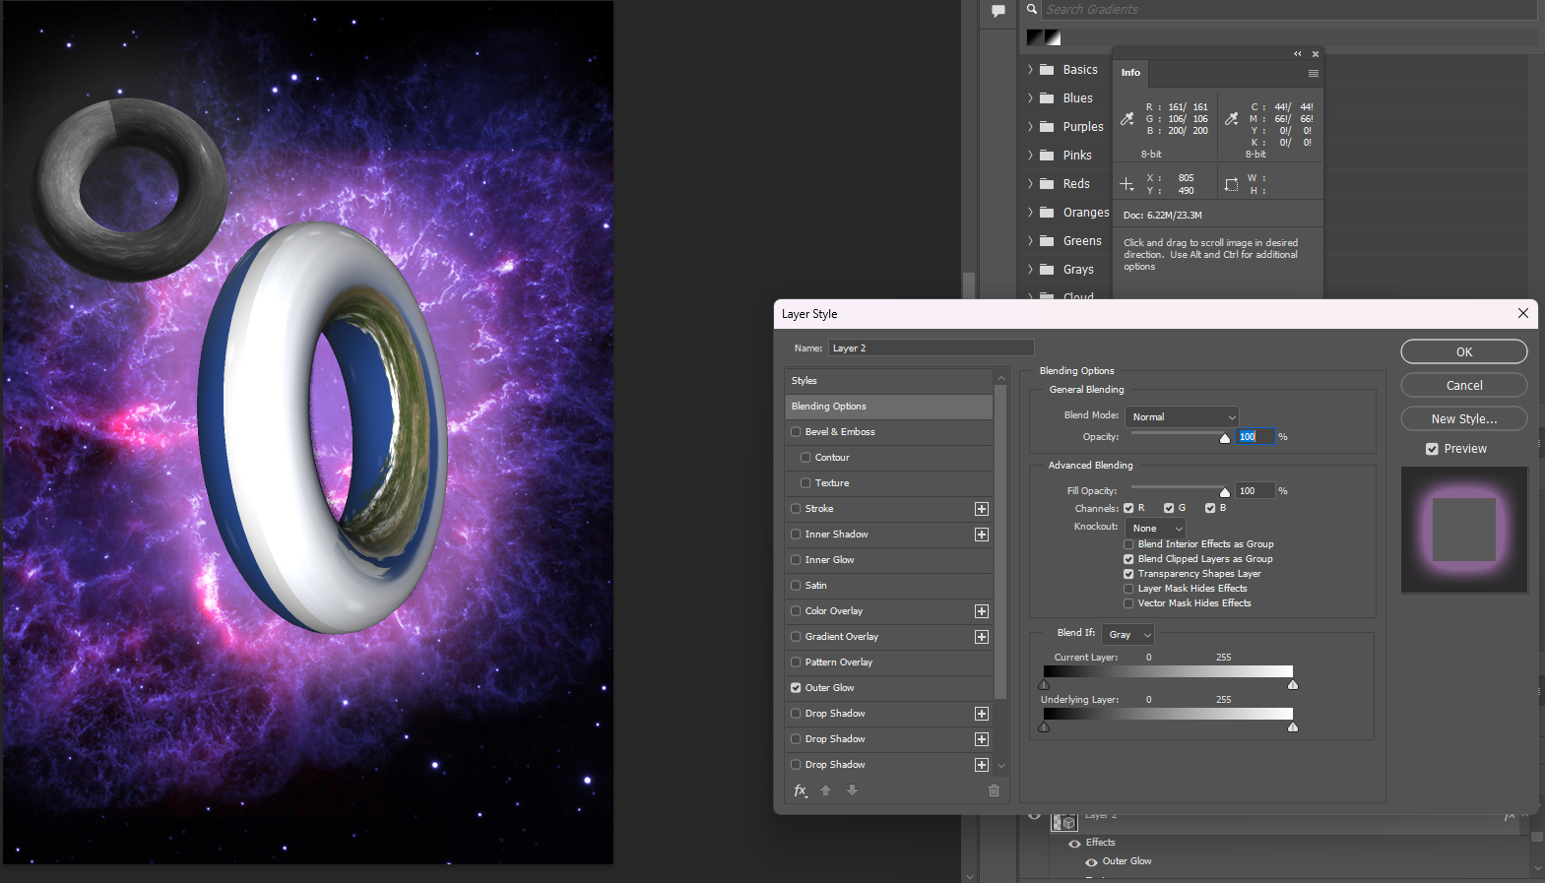

**Some blending adjustments**

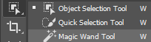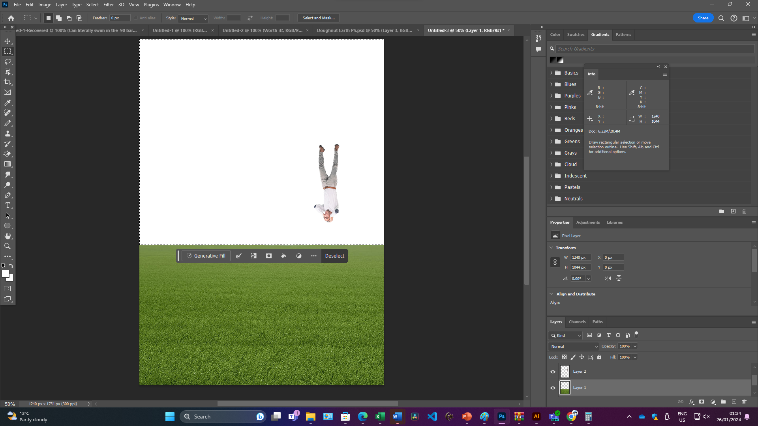

**Removing sky using object selection tool**

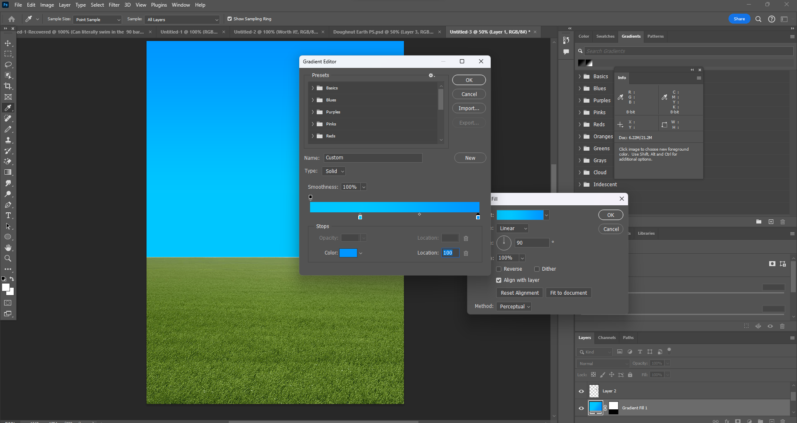

**Replacing sky with gradient to add clouds on top of**

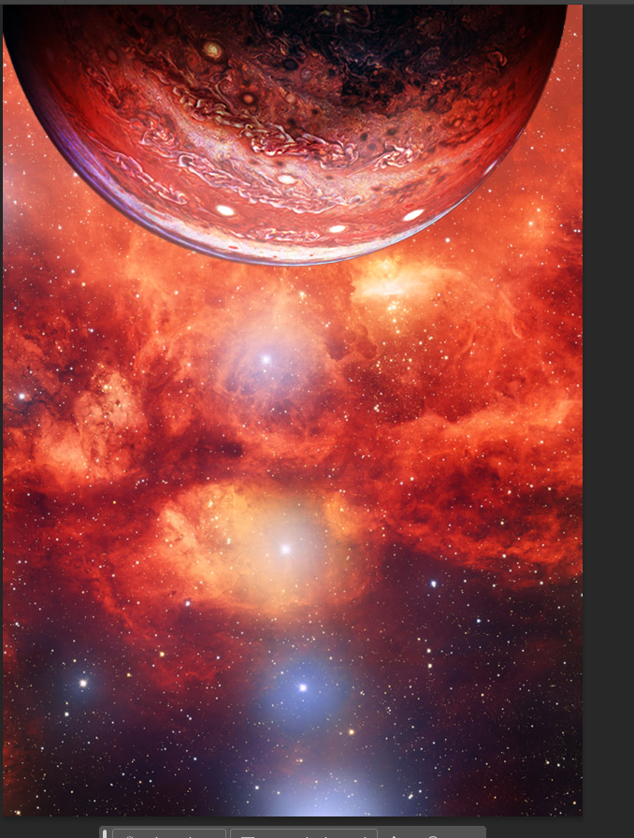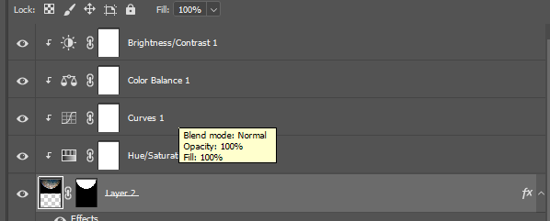

**Use of clipping masks and colour correction to adjust only jupiter’s colour data.**

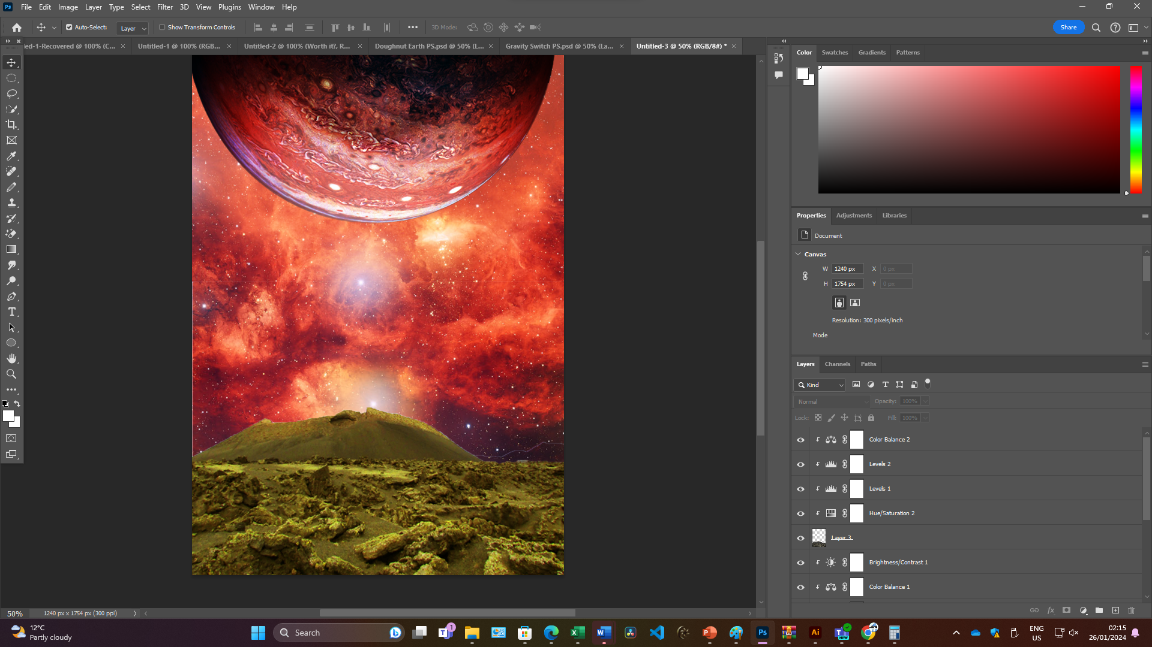

**Same for landscape**

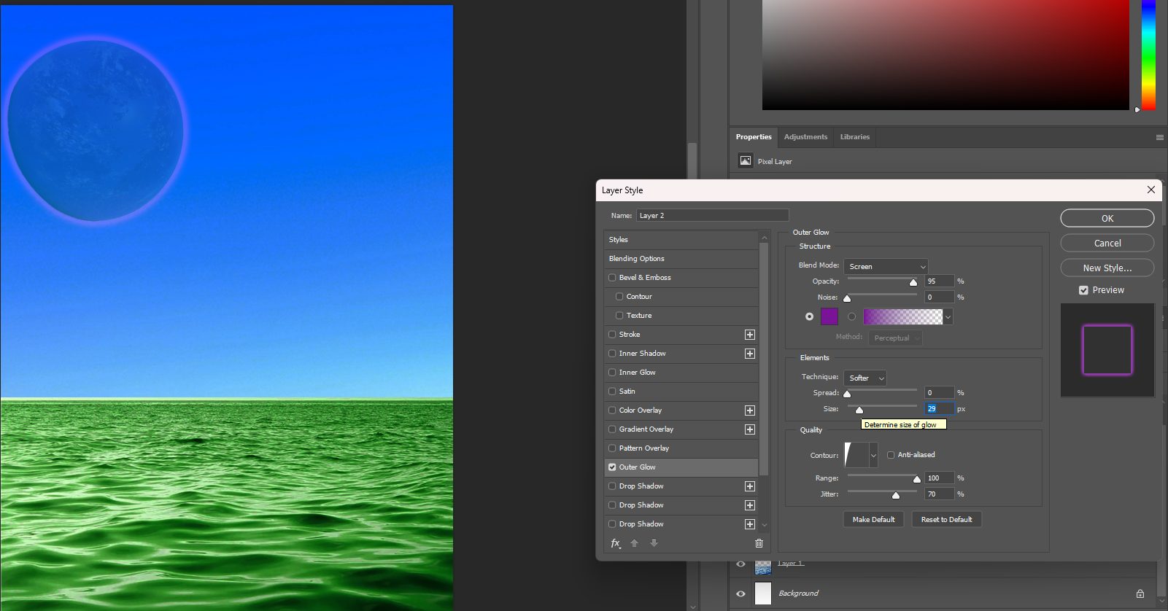

**Adjusting outer glow and opacity of purple planet to make it seem more realistic.**

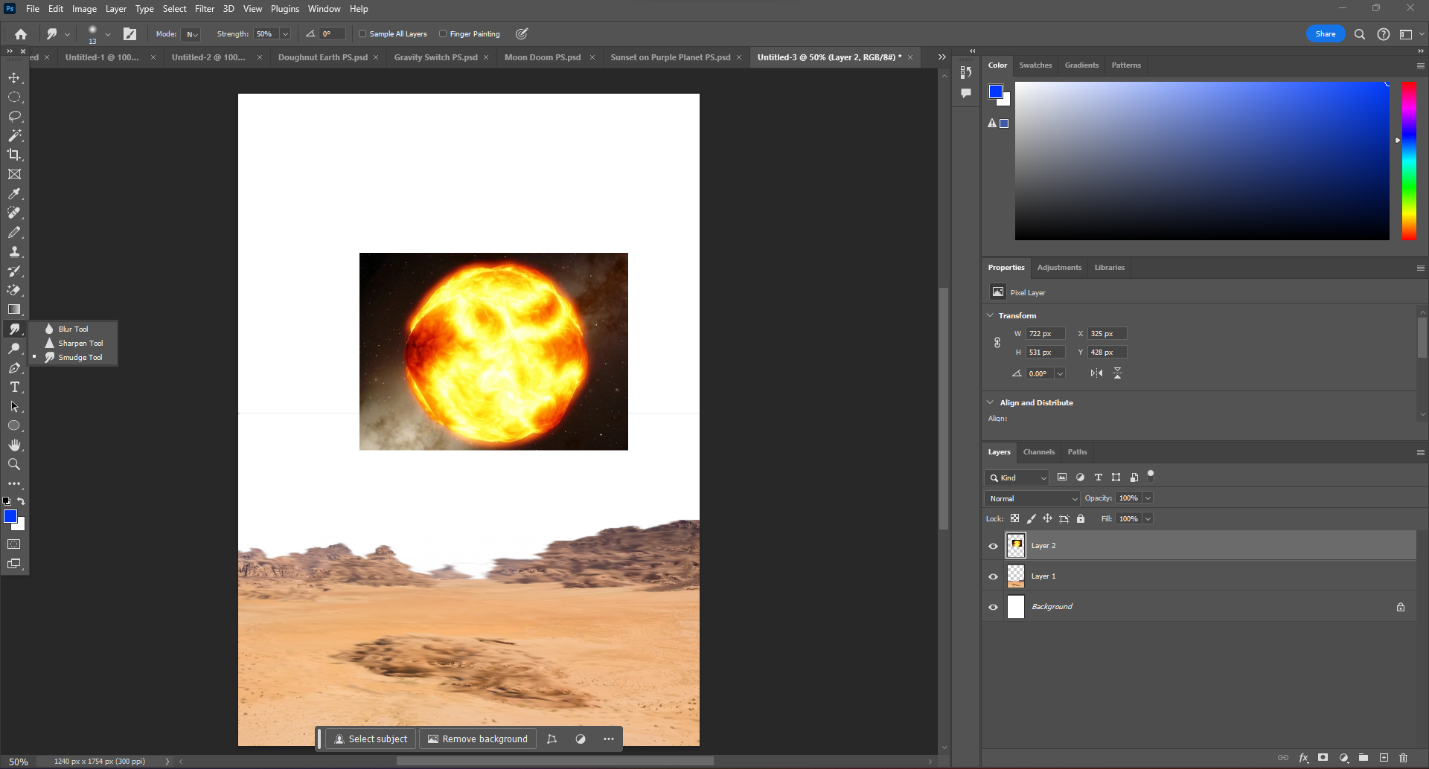

**Using the smudge tool to add a “heatwave effect”**

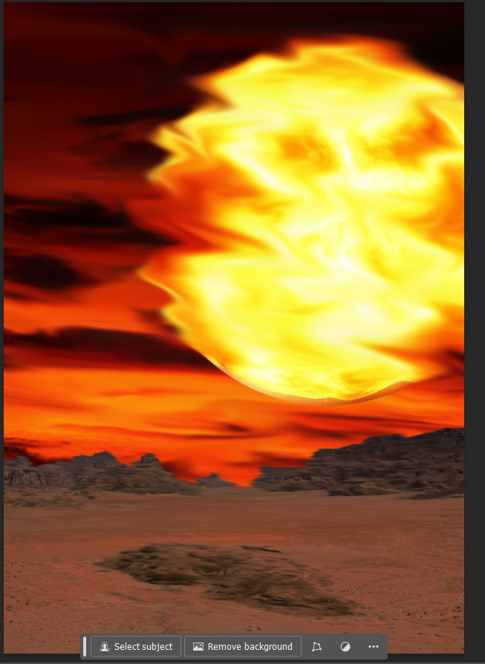

**Final Result**

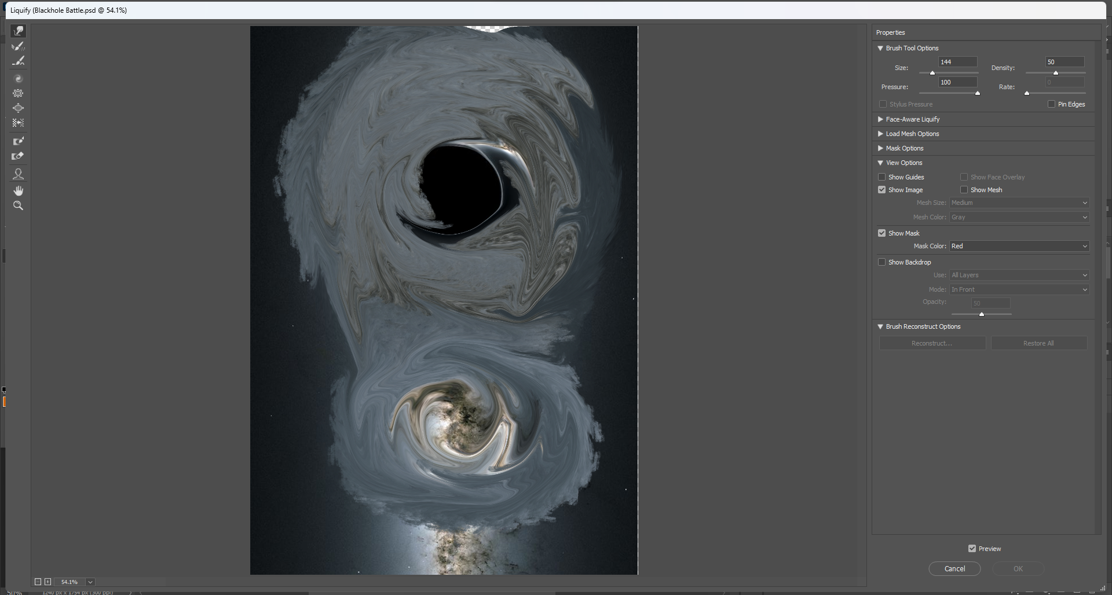

**Used liquify tool to distor image similar to how a black hole distorts space.**